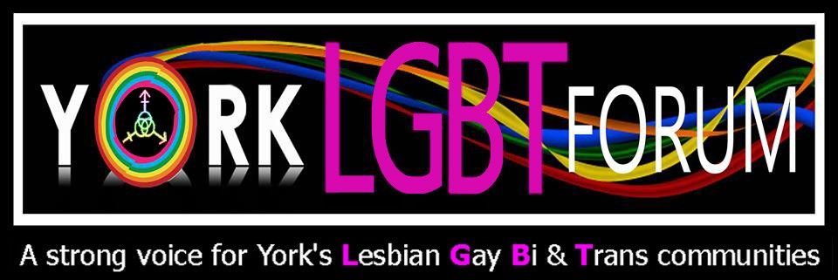

York LGBT Forum Strategy 2017 – 2020
Issue 1

Contents
1. About Us 1
2. Areas We Cover 2
3. Structure of the Forum 3
4. Philosophy 4
5. 2017-2020 Current Projects 5
Subgroup 1: Health and Wellbeing 5
Project 1.1: Mental Health Support 5
Project 1.2: Access to Health Services 6
Project 1.3: Social and Friendship Groups 6
Project 1.4: Social Hub 6
Project 1.5: Coffee Morning 7
Project 1.6: Phone Line 7
Project 1.7: True Colours Theatre 7
Project 1.8: Photography Course 7
Project 1.9: Distribute LGBT research to Health and Wellbeing providers 7
Subgroup 2: Older People 8
Project 2.1: Free to be Me Training 8
Project 2.2: Ageing Without Children (AWOC) 8
Subgroup 3: Hate Crime 8
Project 3.1: Hate Crime Support 9
Subgroup 4: Schools and Young People 9
Project 4.1: OutWord Bound 9
Project 4.2: Free to be Me in Schools 10
Subgroup 5: Transgender 10
Project 5.1: Trans-Friendly York 10
Project 5.2: Transgender Workshop 10
Project 5.3: Human Rights Walk 11
Subgroup 6: International 11
Project 6.1: Sexual Minorities Uganda (SMUG) Fundraisers 11
Project 6.2: International Buddying System 11
Project 6.3: Holocaust Memorial Day 11
Subgroup 7: Bisexual 12
Project 7.1: Establish Bisexual Subgroup 12
Subgroup 8: Funding 12
Project 8.1: Establish Funding Subgroup 12
Subgroup 9: Events 12
Project 9.1: Lord Mayor Charity of the Year (2017) 12
Project 9.2: LGBT Days of Celebration Events 12
6. Future Projects 13
Poverty 13
Employment 13
7. Partnerships 13
Lifeline: (Drugs and Alcohol) 13
SASH: Youth Homelessness 14
Care Quality Commission 14
York Pride 14
York LGBT History Month 14
York Teaching Hospital 15
Barnsley LGBT Forum Tick Scheme 15
Universities’ LGBT societies 15
LGBT Youth Groups 15
Relate 16
Yor-Peer Support Group 16
Independent Domestic Abuse Service (IDAS) 16
Survive 16
Appendix 1: 2017-2020 Projects - Condensed Plan 17

- About Us

The York LGBT Forum is a registered charity: a charitable incorporated organisation with membership. We represent the LGBT population of York and aim to achieve equality through campaigning, social activism, conducting research and lobbying the government for change. Our officers are elected as advocates and project coordinators for the LGBT population and its community. We also offer support to the LGBT population through our groups and workshops.
This document sets out the strategy of the York LGBT Forum. This is based on a four year plan and outlines the needs of the York LGBT population and the actions considered necessary to lead to improved equality.
It highlights our projects, research and identifies organisations which could help achieve our goals. The work will be led by subgroups within the LGBT Forum.
This document has been produced by the York LGBT Forum committee. Throughout the four year period, any amendments to this document will be shown as updates at the end of each project description and also summarised in the status column of Appendix 1.
Note: the term LGBT also includes all other minority sexual orientations and gender identity groups.
Our registered address is York LGBT Forum, York CVS, 15 Priory Street, York, YO1 6ET
Website: www.yorklgbtforum.org.uk
Email: yorklgbtforum@gmail.com

- Areas We Cover

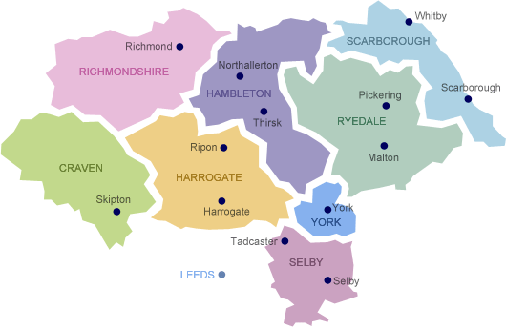

The York LGBT Forum is based in York and the majority of our work is in the city. However we cover York’s surrounding environs in North Yorkshire, working in partnership with organisations such as North Yorkshire Police, OLGA (Older Lesbian Gay Bisexual & Transgender Association) in Scarborough and Yorkshire MESMAC.

Structure of the Forum

York LGBT Forum has a flat line management structure which consists of the membership, who have voting rights, and the committee. The committee includes the subgroup coordinators, two co-chairs, treasurer, and secretary.
This is illustrated below

The Forum has also adopted the holacracy approach to complement the flat line management structure.

Philosophy
This strategy is based on self-actualisation and the ‘Hierarchy of Needs’ theory put forward by the psychologist Maslow (1943). Essentially Maslow noted that before a person can achieve self-actualisation (ie the need to be good, to be fully alive and find meaning in life), the basic needs of humans must be met (eg food, shelter, warmth, security sense of belongingness etc). This document considers Maslow’s theory and gives suggestions on what projects should be developed. Maslow is used extensively in sociological research and therefore it is appropriate to use his theory in a sociological context (Soper and Rosenthal, 1995) for the Forum’s strategy.
Maslow’s ‘Hierarchy of needs pyramid’
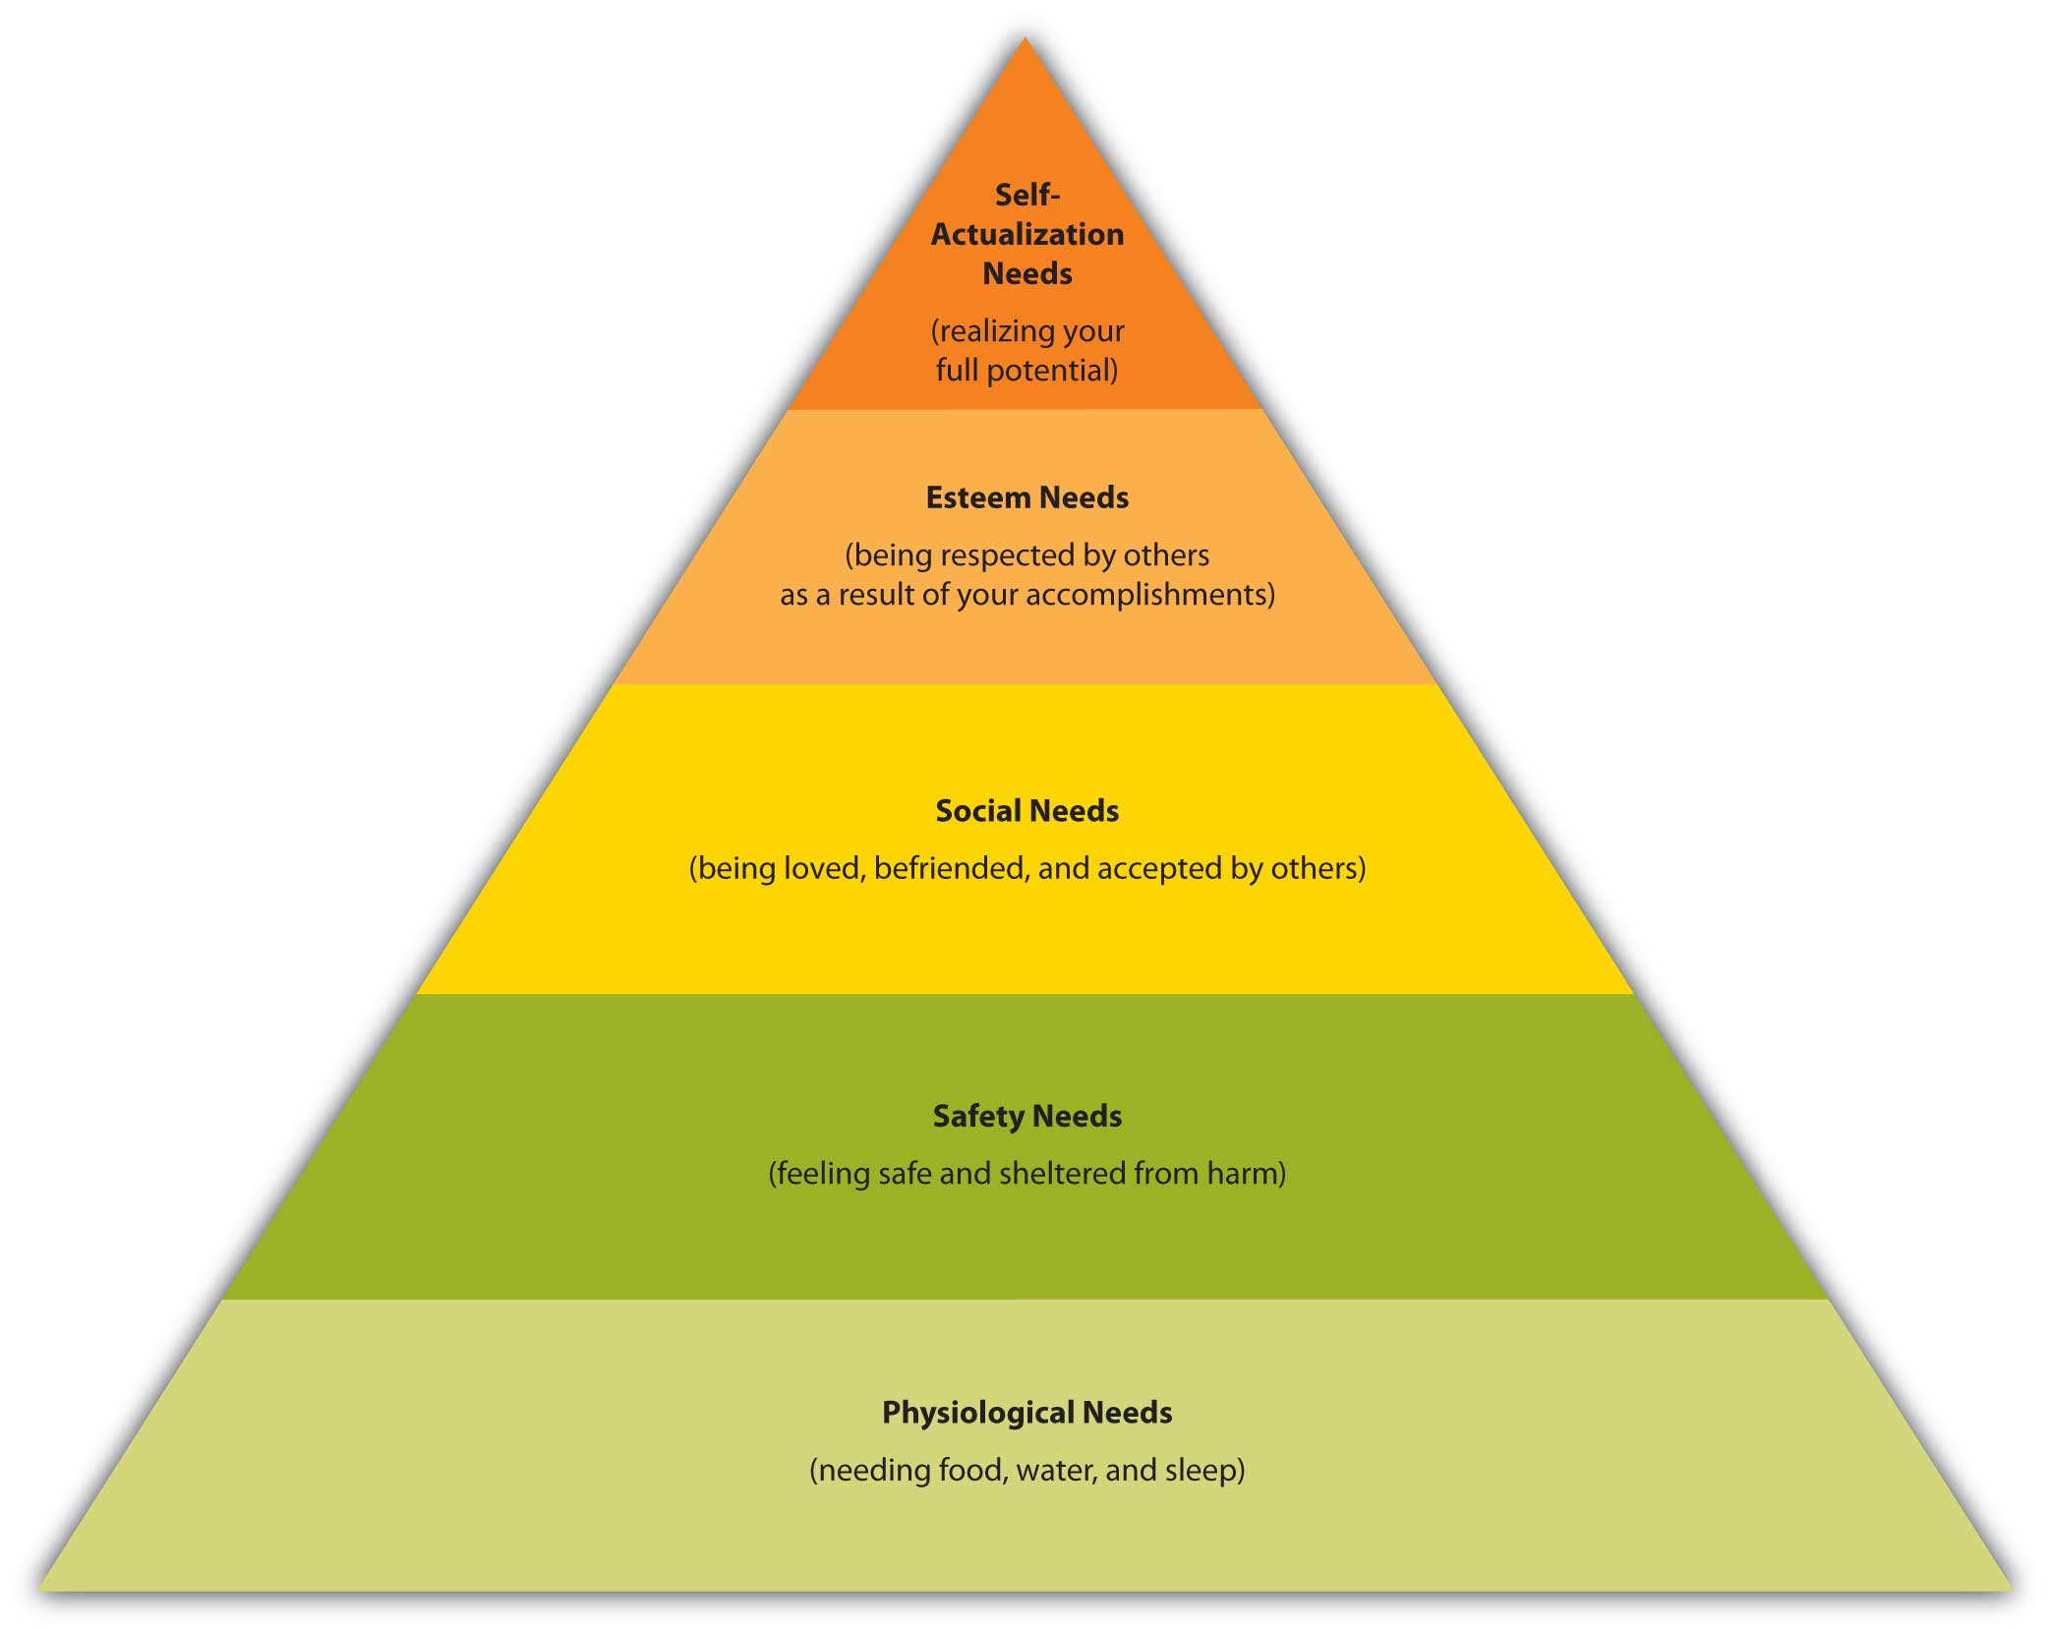
(Web-books, 2013)

2017-2020 Current Projects

In the York LGBT Forum committee meeting dated 25/01/2017 it was decided that projects would replace goals. Each project is allocated to an appropriate subgroup. A further two new categories were added:
- future projects, and
- partnerships.

The nine subgroups are described below together with the projects and costs allocated to each subgroup.

Subgroup 1: Health and Wellbeing
The Health and Wellbeing Subgroup aims to promote equal health and wellbeing for the LGBT people of York. The subgroup does this in a number of ways which include: group work, working in partnership with other organisation and representing LGBT people at relevant meetings.

Project 1.1: Mental Health Support
National research has illustrated that LGBT people have worse mental health outcomes than non-LGBT people. 1 in 3 LGB people have tried to end their own life, this increases in the trans community to 1 in 2. This is a top priority: the Health and Wellbeing subgroup coordinator has set up a mental health peer support group which meets bi-monthly, 1st and 3rd Tuesday of the month.
The York LGBT Forum sits on the Mental Health Forum and has been involved in the City of York Council’s Mental Health and Suicide Plans. We also work closely with the Tees Esk & Wear Valley NHS Trust which operates the statutory mental health support in York.
Costs:
£312 (room hire if we are charged)
£1005 for mental health crisis packs/leaflets/posters/business cards*
£960 training*
* these costs are funded by York CVS and City of York Council.
Total Cost: £2277
Total Cost to Forum: £312

Project 1.2: Access to Health Services
The York LGBT Forum would like to gather data on how LGBT people access health services and what their opinion is of it. We will do this with Healthwatch.
Cost: £0 this might change

Project 1.3: Social and Friendship Groups
We have established a Facebook social group called LGBT Social Group. In the future this could be used to develop a face to face group. The Forum committee members have been meeting people and disseminating information about LGBT groups. We piloted two meetings of the social group. A review has taken place which suggests we need funding to continue with this. The aim is to re-launch the social group when funding is obtained. Six meetings a year are proposed with ten free places at £12 per person (£12 is about the average cost to go to a cinema, theatre, bowling etc).
Costs: £720

Project 1.4: Social Hub
City of York Council has been contacted and dialogue is ongoing. We are looking to share an office with other charities. We have been asked to join a consortium bid of £80,000 for 3 years in which we could have a venue which focuses on health and wellbeing. There are mixed feelings amongst the committee and the members about whether the Forum has the capacity to manage a social hub by itself.
Costs: Approximately £6000 a year without funding.
If funding is not available, this project will become redundant

Project 1.5: Coffee Morning
The free monthly coffee mornings have been successful with an average attendance of 13 people. It has helped to reduce isolation within the LGBT community. It has been running for 2 years.
Costs: £60 a year

Project 1.6: Phone Line
To set up a support line for LGBT people. This will act as a switchboard which will refer people on to other organisations if the call is outside our remit.
Costs: £10 a month if needed

Project 1.7: True Colours Theatre
It was decided that a drama group would help improve people’s confidence and mental health. The drama group will add to the culture of the LGBT and wider community. The drama group is going well, rehearsals are ongoing and it will be putting on two shows this year, starting with ‘Vincent River’, a play covering hate crime.
Costs for the first play:
£320 for play rights
£170 printing
£33.89 props
After all costs, this play raised a surplus of £47.85.

Project 1.8: Photography Course
An annual six-part course in basic photography leading up to York Pride has been set up for people interested in improving their photographic skills.
Costs to be verified

Project 1.9: Distribute LGBT research to Health and Wellbeing providers
This project has arisen from the Forum’s work with partner organisations as some are not aware of recent government LGBT research documentation published by the Department of Health. We have been working hard sharing our resources with health partners.
Costs: £0

Subgroup 2: Older People
The Older People’s Subgroup aims to promote awareness of Older LGBT People in York and the surrounding areas. It does this by advocating and supporting older LGBT people by attending meetings, running groups and providing training for care homes.

Project 2.1: Free to be Me Training
The Older People’s Subgroup has been active in gathering research and from this it has developed a training package for staff in care homes. The subgroup has also developed the training for use in the workplace. The training is a government recognised programme.
Costs:
This is an income-generating project:
£80 charged per session for Free to be Me in the workplace
£100 charged per session for Free to be Me in care.
In 2016 it raised: £1016

Project 2.2: Ageing Without Children (AWOC)
It is estimated that around 90% of LGBT people are ageing without children. A local group, AWOC York, was formed with an open-door welcome for anyone who is ageing without children for whatever reason. The group has strong links to the Forum and meets on the 2nd Wednesday of each month.
Cost: £0 this might change

Subgroup 3: Hate Crime
This subgroup has been set up to raise awareness and offer support to people who have suffered a hate crime because of their sexual orientation and/or gender identity. We work closely with the police and offer them LGBT training

Project 3.1: Hate Crime Support
Hate Crime is a major issue in the LGBT community. Our aim is to increase and encourage the reporting of hate crimes to the police and offer support to survivors of hate crime. We have police liaison officers from North Yorkshire Police who report to us current LGBT Hate Crime statistics. Together with these police officers we lobby for LGBT hate crimes to be recognised in the police force. We have delivered LGBT training to the police and they have set up an LGBT staff network.
Costs:
Stop Hate Wrist bands - 100 for £40.00
Stop Hate Leaflets - 100 for £20.00
Schools Ok to be Gay poster - 100 for £10.00
Schools OK to be Gay postcards - 1000 for £20.00
Queer Cards - 1000 for £20.00
Hate Crime Car Stickers for Taxis - 1000 for £60.00
Beer Mats 500 for £60.00
Report Cards - Free.
Purchase Costs: £230

If all wristbands were sold this could raise £100
Projected total cost: £130

Subgroup 4: Schools and Young People
The Schools and Young People Subgroup aims to source & provide access to a multitude of LGBT-related resources. We have an annual writing competition in local schools and our future aim is to develop a training programme for school teachers.

Project 4.1: OutWord Bound
The York LGBT Forum has been working in schools to raise LGBT awareness. We have developed a writing competition in partnership with York LGBT History Month which is LGBT-themed and has become an annual event. The entries submitted have been made into a booklet. We have also donated an LGBT-themed book to every school in 2015 and 2016; this will also become an annual event.
Costs (2017):
£185.70 for books
£300 for prizes
£90 for booklet
Total Cost: £575.70

Project 4.2: Free to be Me in Schools
We are developing Free to be Me for schools as part of our awareness training.
Costs: needs to be verified.

Subgroup 5: Transgender
The transgender subgroup was set up to represent, support and provide awareness of trans people. This is achieved through representing trans people at meetings, creating safe places for socials and offering advice via workshops.

Project 5.1: Trans-Friendly York
It has been suggested by members of the Forum that York is not a trans-friendly city and we wish to change that. This goal will meet the criteria for York becoming a Human Rights city.
To help trans people feel less isolated and safe we run a regular trans night every third Saturday at Thomas’s of York.
Costs: £0

Project 5.2: Transgender Workshop
84% of trans people consider suicide and 48% try to commit suicide. There is a 3 – 4 years waiting list before a trans person can get a first appointment at the Leeds Gender Clinic. The lack of support for trans people in the York area and the mental health crisis amongst the trans community is why the Forum needs to provide support. The Forum transgender workshop has been very successful and will be rolled out across the Leeds Gender Clinic catchment area. It is the only such workshop in the UK.
Costs: £80 (costs of 4 meetings per year to cover food). This might change if the workshop goes on outreach

Project 5.3: Human Rights Walk
It was decided that we should assess how safe York is for LGBT people. A series of holding-hands walks involving LGBT people was undertaken within the city. From initial results York seems very safe but more research is needed before a conclusion can be drawn. Owing to the success of the walks more are planned to take place in 2017.
Costs: £0

Subgroup 6: International
The York LGBT Forum has recognised the ongoing struggle for LGBT people across the world.

Project 6.1: Sexual Minorities Uganda (SMUG) Fundraisers
We are focusing on Uganda as it was decided to support one cause for greater impact. There have been a total of 4 fundraisers so far and over £1000 has been raised for safe houses in Uganda.
Costs: £200 (costs of 4 fundraisers per year to cover food).

Project 6.2: International Buddying System
The York LGBT Forum would like to Buddy with emerging LGBT organisations across the world. We have decided to focus on Poland, a country where it is legal to be LGBT but face much discrimination.
Costs to be verified

Project 6.3: Holocaust Memorial Day
To sit on and provide events for Holocaust Memorial Day.
Costs to be verified

Subgroup 7: Bisexual
The York LGBT Forum is aware that often bisexual people are not well-represented in LGBT organisations. Therefore it was decided to set up a bisexual group so it can promote, support and provide awareness of bisexual issues.

Project 7.1: Establish Bisexual Subgroup
To establish a bisexual group and set their aims and goals.
Costs to be verified.

Subgroup 8: Funding
It was decided that it would be desirable to set up a funding subgroup to consider fundraising, the application for grants and sponsorships.

Project 8.1: Establish Funding Subgroup
A funding group has been set up. The subgroup needs more volunteers to help source funding and fundraising. It should be noted that this is a mid/long term goal owing to the forthcoming contribution from the Lord Mayor’s Charity.
Costs: £0

Subgroup 9: Events
The York LGBT Forum would like to establish regular events for LGBT people and the wider community. These events will raise LGBT awareness and in some cases provide a fundraising opportunity.

Project 9.1: Lord Mayor Charity of the Year (2016 - 2017)
Attend Lord Mayor Charity Committee and put on some fundraising events.
Costs: £0
Projected Income: £10,000

Project 9.2: LGBT Days of Celebration Events
Organise events on days of celebration and landmarks of LGBT rights.
Costs to be verified.

Future Projects

The York LGBT Forum has planned the following projects for the future

Poverty
The project’s aim is to study LGBT Poverty in York. There is very little data nationally about LGBT people being in poverty and this would be ground-breaking research. Owing to time constraints and lack of volunteers, this goal was not initiated until late in 2016.
Joseph Rowntree Foundation are eager to fund us to do the research if we can get a team of volunteer researchers. This goal is ongoing and it is hoped that this will be achieved in the future.
Subgroup Coordinator: N/A
Cost: £0 owing to funding by Joseph Rowntree Foundation

Employment
This goal was to examine LGBT employment statistics and to see if LGBT people are discriminated against. Owing to the limited resources of the York LGBT Forum and the scope of this project, it was decided this project was too big for us to achieve currently.
Subgroup Coordinator: N/A
Costs: £0

Partnerships

Lifeline: (Drugs and Alcohol)
National data indicates that LGBT people have higher incidences of drug and alcohol dependency. Our partners, Yorkshire MESMAC and Lifeline, started to run a support group for LGBT people with drug and alcohol dependency but, owing to lack of attendance, this was stopped. However, the York LGBT Forum has made a close link with Lifeline and we will be looking at ways to encourage LGBT people to access their services.
Subgroup: Health and Wellbeing
Cost: £0 this might change

SASH: Youth Homelessness
We are aware that young LGBT homelessness is high nationally and based on this data from 2017 we will be working with SASH, a homeless charity in York, on a small joint project to help address this issue.
Subgroup: Health and Wellbeing
Costs: £50 donation so far

Care Quality Commission
This liaison has arisen from research by the Older People’s Subgroup. They have identified the need to critique the CQC Monitoring Policy, as there is a lack of evidence of support for LGBT persons. We have been in dialogue with the CQC and are lobbying for change.
Subgroup Coordinator: Co-Chair
Costs: £0

York Pride
We have regular contact with York Pride and have worked together on projects. We look forward to our continuing relationship.
Subgroup Coordinator: Co-Chair
Costs: £0

York LGBT History Month
We have regular contact with York LGBT History Month and work together on the OutWord Bound Project.
Subgroup: Schools and Young People
Costs: £0

York Teaching Hospital
To support and advise the Equality and Diversity Facilitator at the York Teaching Hospital.
Subgroup: Health and Wellbeing
Costs: £0

Barnsley LGBT Forum Tick Scheme
Contact has been established with the Barnsley LGBT Forum which runs its own accreditation tick scheme. A similar tick system would require a great deal of work although it would generate income. It was decided that we would not go ahead with an accreditation scheme at the present time.
Subgroup Coordinator: Co-Chair
Costs: This would be an income generating project.

Universities’ LGBT societies
The York LGBT Forum has worked with both universities’ LGBT societies and we keep in regular contact. We hope to develop a student wing to the Forum and encourage students to volunteer with us.
Subgroups: Health and Wellbeing and Schools and Young People
Costs: £0

LGBT Youth Groups
We have contacted the Youth Group run by Yorkshire MESMAC as there is a possibility that the Youth Group funding might be stopped. The York LGBT Forum has been an advocate for this vital service and has been in consultation with the City of York Council. The York LGBT Forum will continue to be in dialogue with Yorkshire MESMAC
Subgroup: Schools and Young People
Costs to be verified.

Relate
Discussions have been held with Relate in York and they have offered their counselling services for use by LGBT people referred to them by the Forum.
Subgroup: Health and Wellbeing
Costs to be verified.

Yor-Peer Support Group
York LGBT Forum has established contact with Yor-Peer Support Group and set up a joint partnership offering peer support for people with mental ill-health.
Subgroup: Health and Wellbeing
Costs: refer to project 1.1.

Independent Domestic Abuse Service (IDAS)
We have been in discussions with IDAS about LGBT domestic violence and plan to work together on domestic abuse in LGBT relationships.

Survive
We work to raise awareness of LGBT sexual abuse with Survive.

Appendix 1: 2017-2020 Projects - Condensed Plan

The document is colour coded
Red: Not started
Orange: In progress
Green: Established
Subgroup | Project No | Name of Project | Brief Description | Status
1. Health and Wellbeing | 1.1 | Mental Health Support | Mental Health Peer Support Group | Regular Meetings: 1st and 3rd Tuesday of the Month. Receiving training in March
 | 1.2 | Access to Health Service | Access to Health Service with help from Healthwatch | Healthwatch has been contacted
 | 1.3 | Social and Friendship Groups | Facebook Group and Face to Face Social Group | Facebook – Done  Face to Face – Relaunch in July 2017
 | 1.4 | Social Hub | Establish a social hub | Awaiting a response as we have bid for funding
 | 1.5 | Coffee Morning | Monthly Coffee Morning Social | Regular Meetings 1st Saturday of the Month
 | 1.6 | Phone Line | Change hate crime line to phone line which offers support/signposting | Final Details being sorted
 | 1.7 | True Colours Theatre | Drama group to help improve people’s confidence and mental health | First play ‘Vincent River’ showed in March 2017
 | 1.8 | Photography Course | Annual six-part course in basic photography leading up to York Pride | Course started
 | 1.9 | Distribute LGBT research to Health and Wellbeing providers | Share health and wellbeing resources with health partners | Ongoing: resources given to a number of Health and Wellbeing organisations.
2. Older People | 2.1 | Free to be Me Training | Training for care homes and in the workplace | Regular training given
 | 2.2 | Ageing Without Children (AWOC) | Advice/social group set up for people ageing without children | Regular meetings 2nd Wed of the month
3. Hate Crime | 3.1 | Hate Crime Support | Liaise with police, raise awareness of hate crime. | Regular meetings and updates
4. Schools and Young People | 4.1 | OutWord Bound | Writing Competition in Schools/ Book Donation | Annual Event
 | 4.2 | Free to be Me in Schools | Develop Free to be Me training for schools | Not started
5. Transgender | 5.1 | Trans Friendly York | York Third Saturday making York a Trans friendly place | Every third Saturday
 | 5.2 | Transgender Workshop | Provide advice for trans people | Every Quarter workshop takes place – could be replicated across Leeds Gender Clinic Catchment areas
 | 5.3 | Human Rights Walk | How safe is York for trans and LGB people | Regular walks to monitor how safe York is
6. International | 6.1 | SMUG Fundraisers | To raise money for SMUG | 4 x SMUG Fundraisers a year
 | 6.2 | International Buddying System | To pair with LGBT organisations across the world starting with Poland | Field research being undertaken
 | 6.3 | Holocaust Memorial Day (HMD) | To sit on and provide events for HMD | Contact to be made in 2018
7. Bisexual | 7.1 | Establish bisexual subgroup | To set up a bisexual subgroup | Bisexual subgroup twitter set up. Planning future socials.
8. Funding | 8.1 | Establish Funding subgroup | To set up funding subgroup | Funding subgroup set up - needs more volunteers
9. Events | 9.1 | Lord Mayor Charity of the Year | To sit on committee. To organise fundraisers | We attend regular meetings and organise fundraisers
 | 9.2 | LGBT days of celebration events | To put on events for LGBT landmarks and celebrations | Some events have been done i.e trans day of awareness. Secretary has compiled a list of awareness events and their dates.
Subgroup to be decided | N/A | Future Projects – Poverty | To research LGBT poverty in York | Joseph Rowntree Foundation would fund us if we can get a team of researchers
Subgroup to be decided | N/A | Future Projects - Employment | To research LGBT employment | Not Started
N/A | N/A | Partnerships | To be in contact with our partners and encourage LGBT accessibility.  Partners include:  Lifeline  SASH  Care Quality Commission (CQC)  York Pride  York LGBT History Month  York Teaching Hospital  Barnsley LGBT Forum  Universities’ LGBT Societies  LGBT Youth Groups  Relate  Yor-Peer Support Group  Independent Domestic Abuse Service (IDAS)  Survive | Ongoing talks with partners.

